**Experiment No: 04**

**Booking, GIS & Admin Module**

**Aim**: Working of Taxi booking, GIS and Admin Module for Taxi Rental Website

**Theory: 1] Taxi Booking Module:** This module is basically allow the user to book the taxi whenever they want. After successful authentication the user will be directed to a page where it will show the BOOK NOW button and also the confirm bookings. Once they click that button it will direct them to a page where it will ask the user to enter their pick up and drop of point and also date and time when they want to book. Once the user enters the details it will check if the date entered is valid or not. After this it will enter the GIS module. Once it is completed then it will allow the user to book the taxi which are available. Along with that it will show all the details of the taxi. After clicking the BOOK NOW button it will process the request and confirm the booking. Then a message will be displayed showing your booking is successful. User can view their bookings as well as cancel the bookings. In the database all the taxi details and booking details are stored.

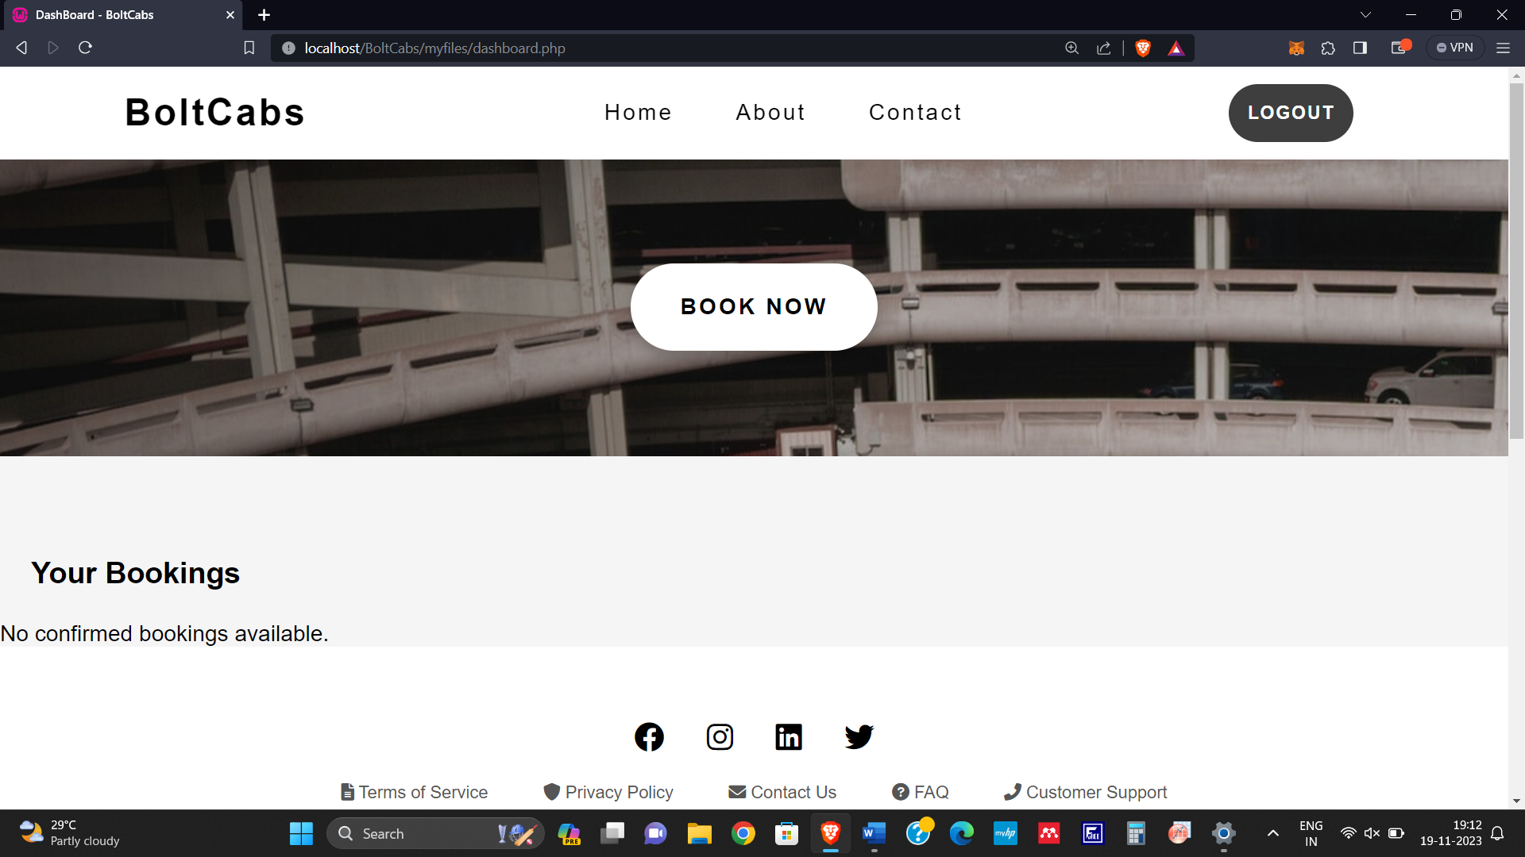

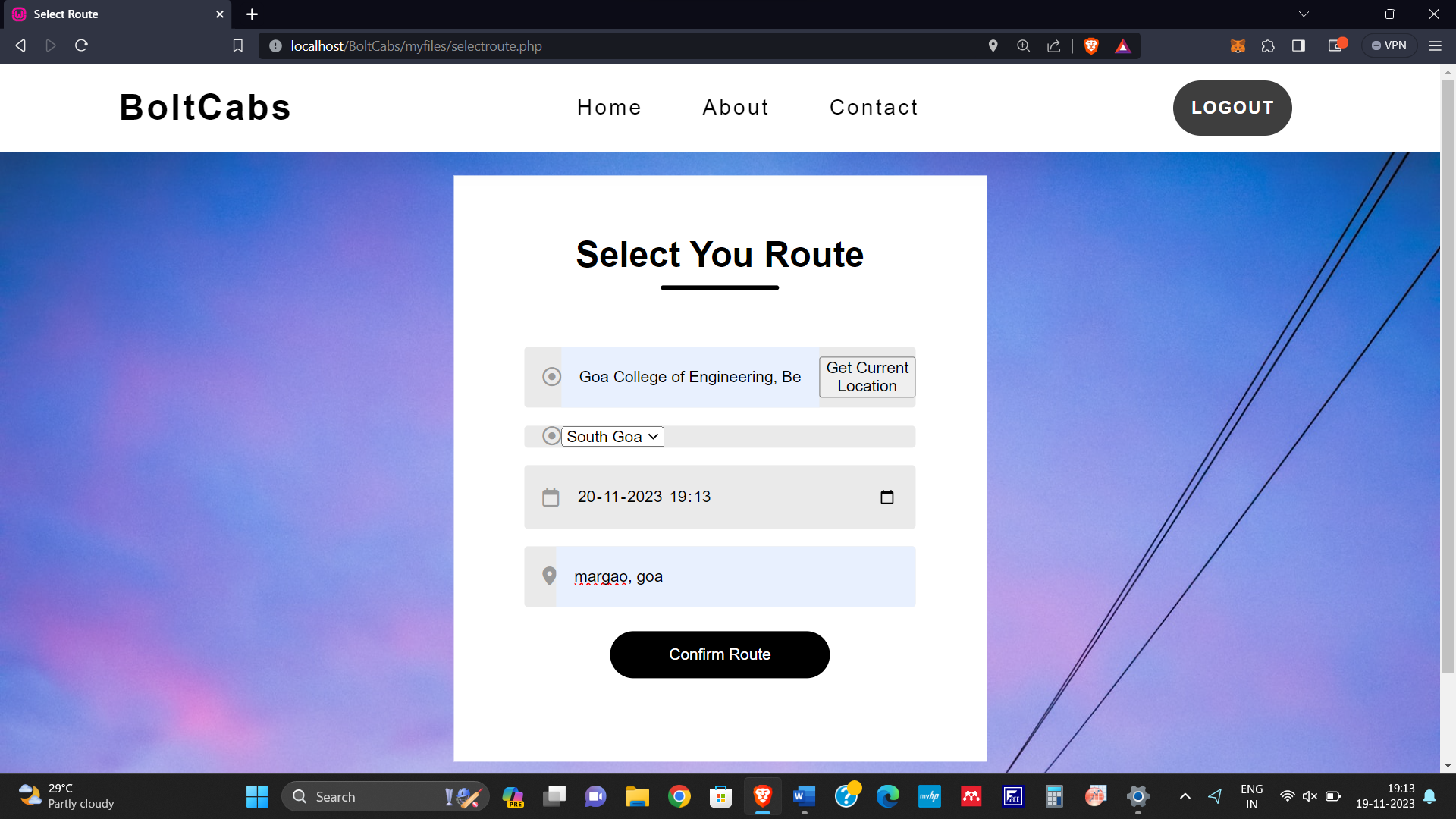

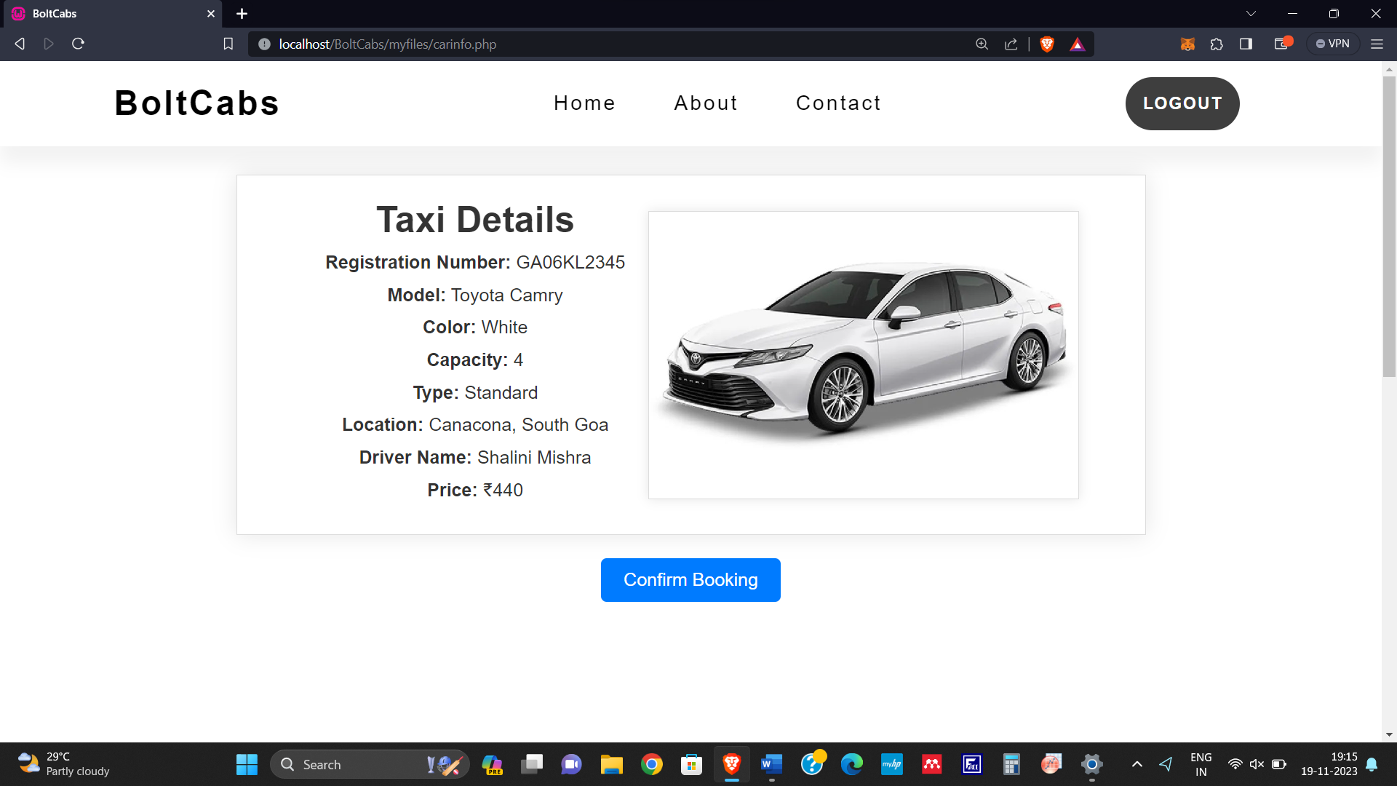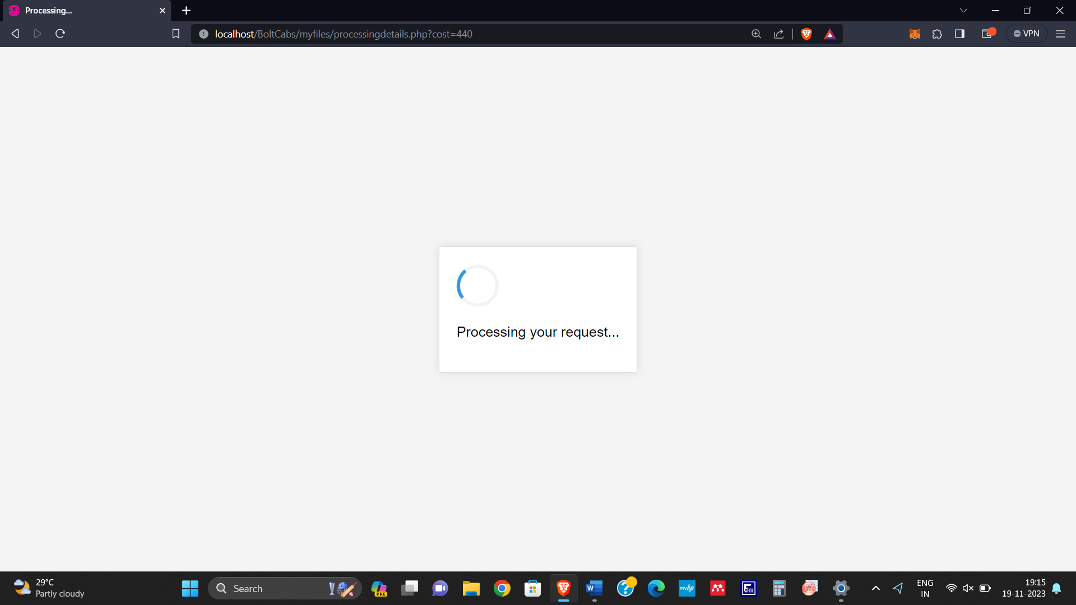

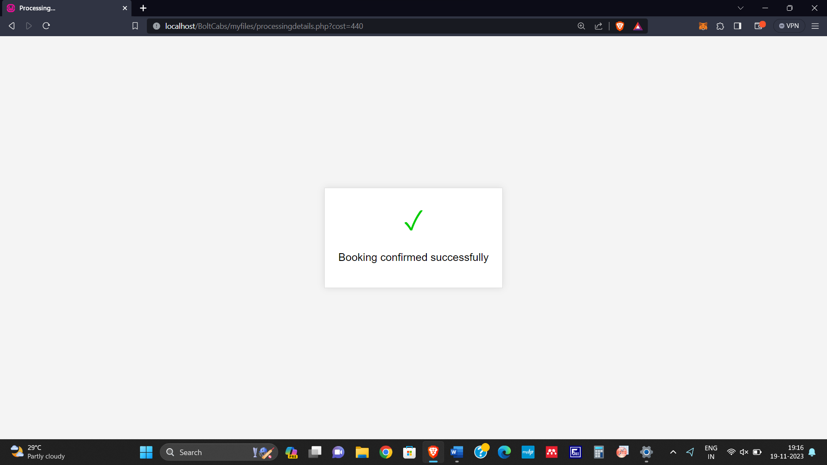

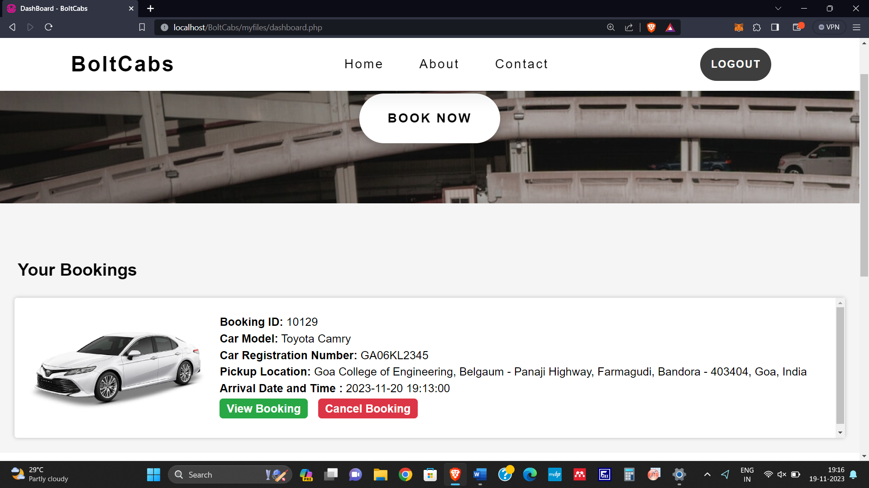

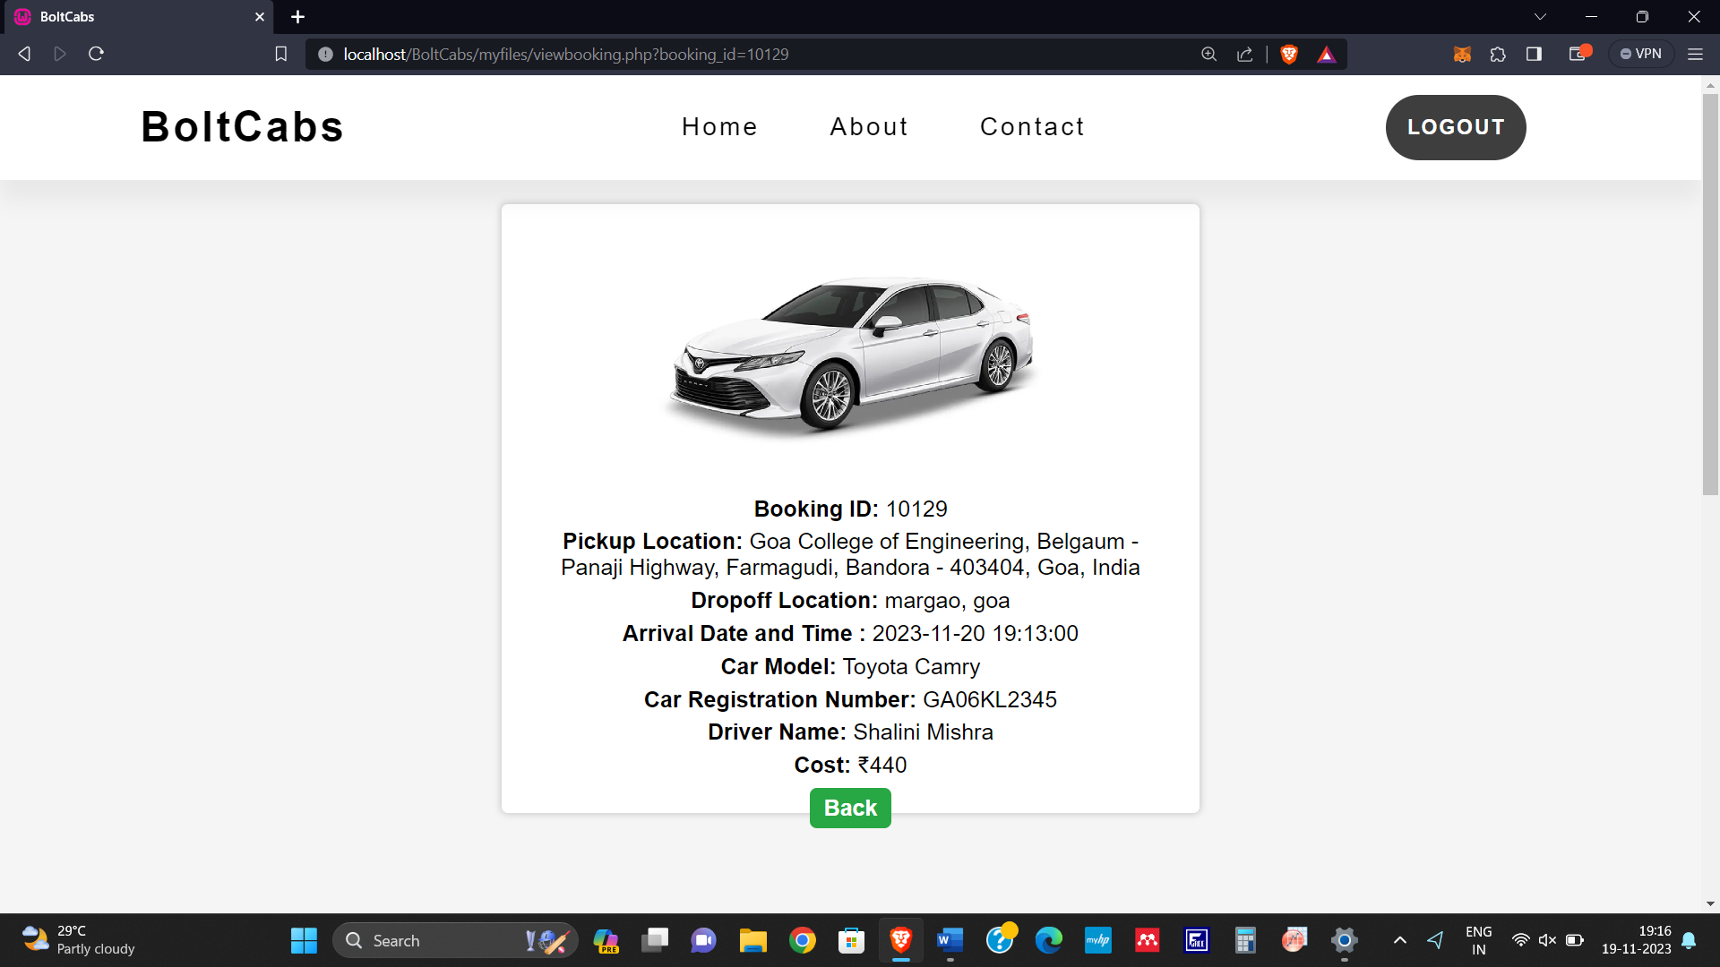

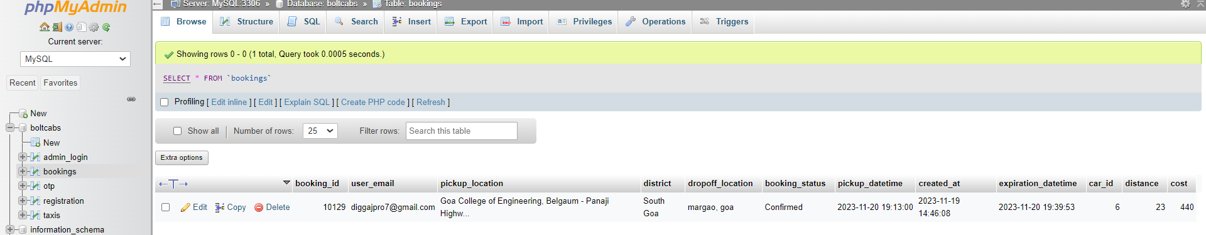

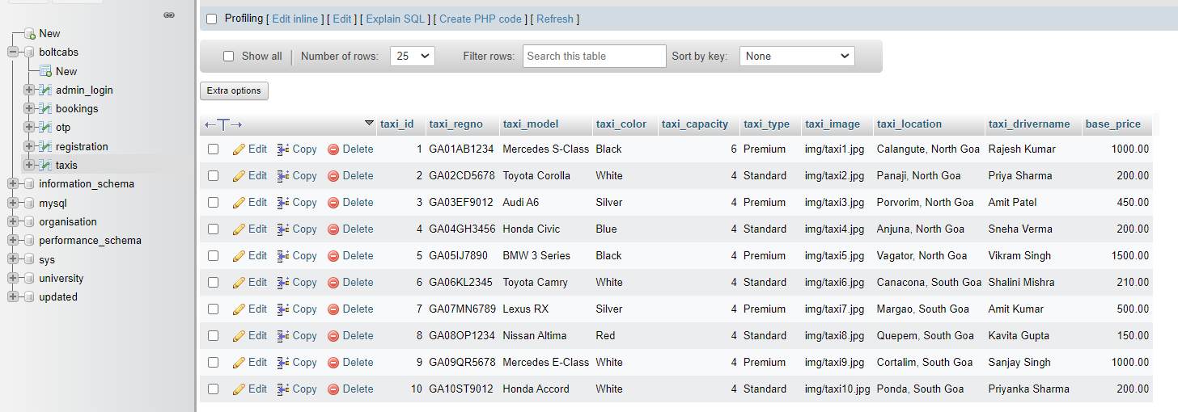

**2] GIS and Mapping Integration Module:**

This module focuses on the GIS and finding the route from the pick up location and the drop off location. First it will ask user to enter the pick up location. The user can directly get the current location also. Then it will take the date, time and the drop off location. After that with the help of GIS it will find the best route. Then it will automatically calculate the distance between the two location and also calculate the approximate time it will take to reach there.

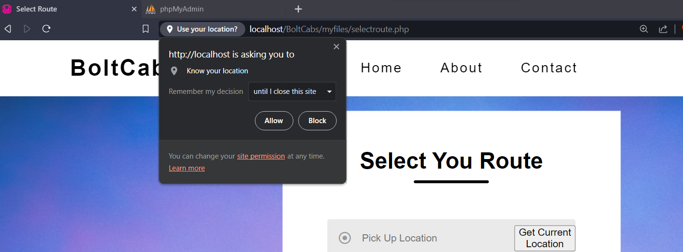

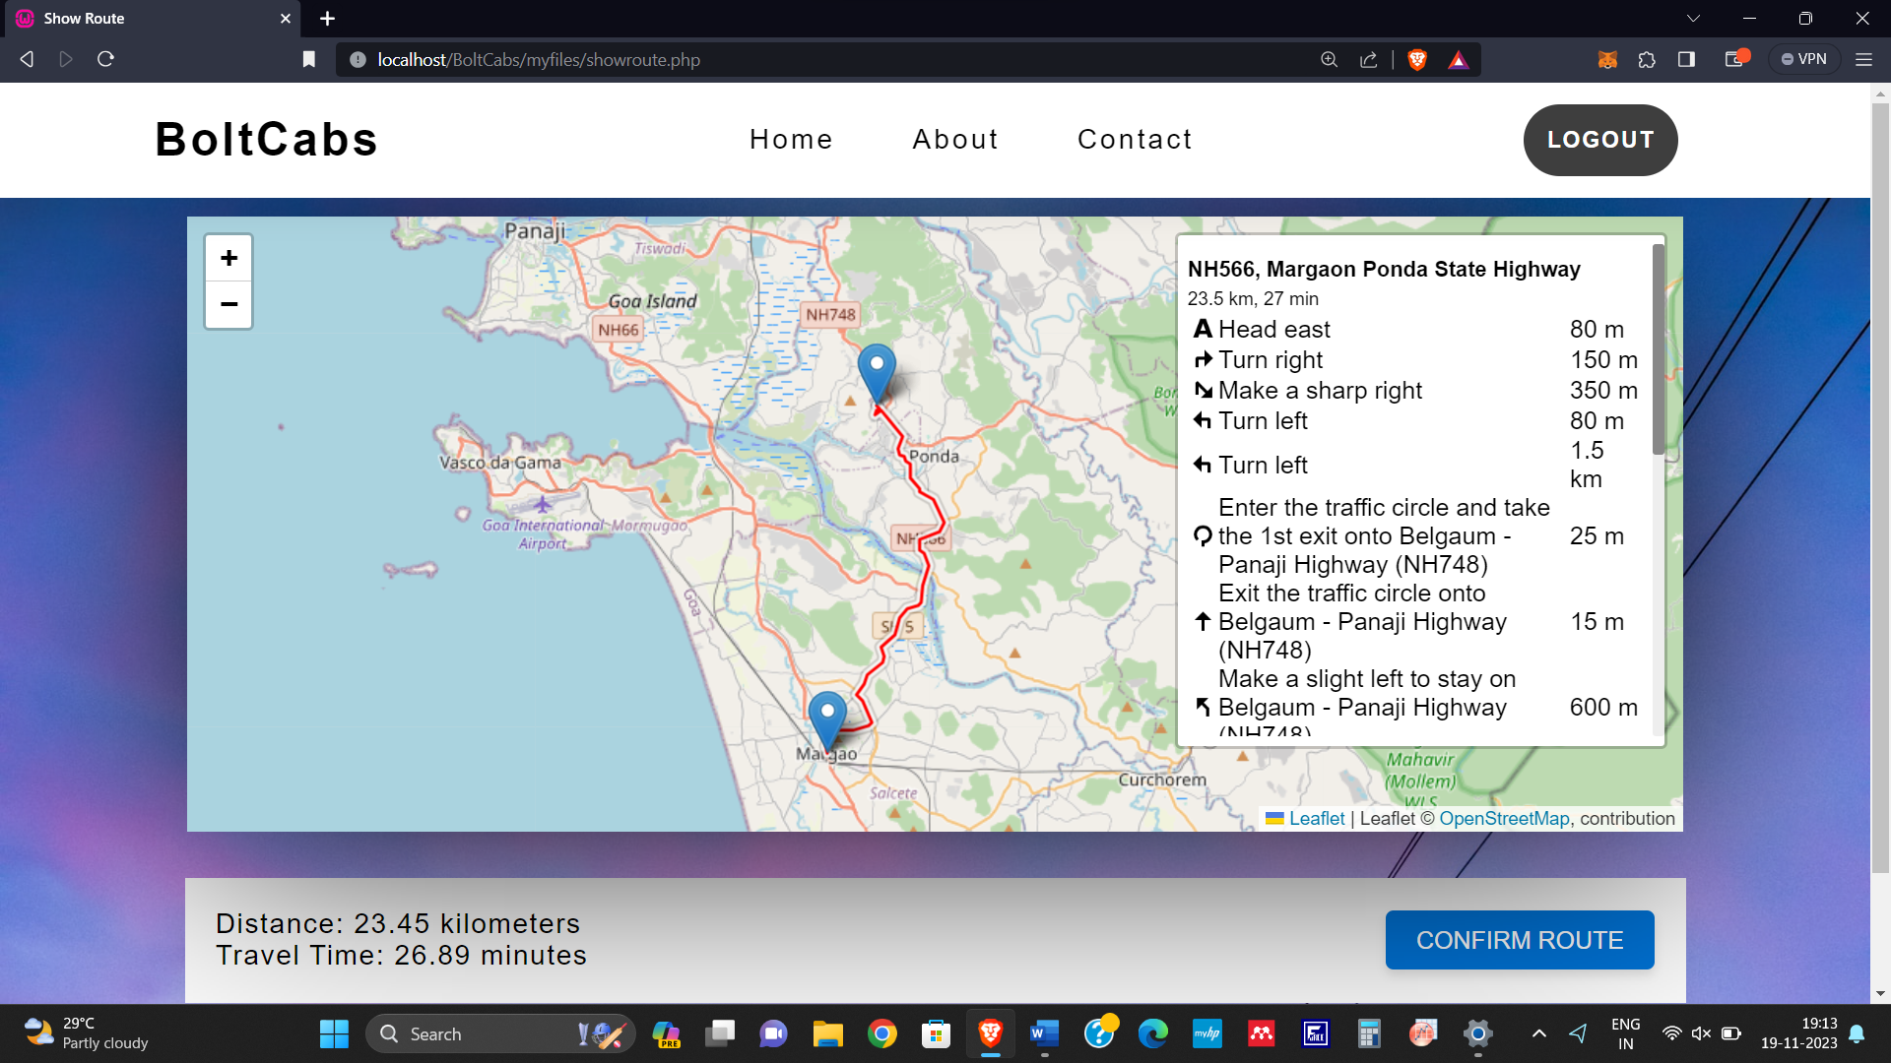

**3] Admin Panel Module:**

The last module is admin module where only the admin have the direct access to make the changes in the database. First it will ask the admin to signin. Then it will verify the details of Admin. Once the authentication is done than it will display the dashboard where it will show the number of user, taxis, drivers and total bookings. In the user section the Admin can see all the user details as well as can edit or delete the details of user. In the car & driver section it will show all the taxi details along with the driver assign to it. The admin can edit, delete as well as add new taxi to the database. The next section that is booking section. The Admin can view the details of booking as well as edit and delete the booking details. Then the admin can logout for there. All the changes made here will get reflected back in the database.



